# Enhanced Deep Learning Techniques for Rainfall Forecasting

***A project report submitted to MALLA REDDY UNIVERSITY***

***in partial fulfillment of the requirements for the award of degree of***

## BACHELOR OF TECHNOLGY

**in**

## COMPUTER SCIENCE & ENGINEERING (AI & ML)

**Submitted by**

## P. Jahnavi : 2211CS020557

**K. Hima Bindhu : 2211CS020573**

## G. Yashaswini : 2211CS020581

**S. Shashidhar : 2211CS020612**

***Under the Guidance of***

## Dr . A. Sivaranjani

**DEPARTMENT OF COMPUTER SCIENCE & ENGINEERING (AI & ML)**

2024



**COLLEGE CERTIFICATE**

This is to certify that this is the bonafide record of the Application Development entitled, **“Enhanced Deep Learning Techniques For Rainfall Forecasting”** Submitted by P.Jahnavi(2211CS020557), K.Hima Bindhu(2211CS020573), G.Yashaswini(2211CS020581),

S.Shashidhar(2211CS020612) B. Tech III year I semester, Department of CSE (AI&ML) during the year 2023-24. The results embodied in the report have not been submitted to any other university or institute for the award of any degree or diploma.

**PROJECT GUIDE HEAD OF THE DEPARTMENT**

**Dr . A. Sivaranjani**

**DEAN CSE(AI&ML)**

**Dr. Thayyaba Khatoon**

**EXTERNAL EXAMINER**

## ACKNOWLEDGEMENT

We would like to express our gratitude to all those who extended their support and suggestions to come up with this application. Special Thanks to our mentor Prof K. Manoj Sagar whose help stimulating suggestions and encouragement helped us all the time in the due course of project development.

We sincerely thank our Dean Dr. Thayyaba Khatoon for her constant support and motivation all the time. A special acknowledgment goes to a friend who enthused us from the backstage. Last but not least our sincere appreciation goes to our family who has been tolerant understanding our moods, and extending timely support.

## ABSTRACT

Rainfall prediction is a crucial aspect of weather forecasting, agricultural planning, and disaster management. Traditional methods for rainfall prediction often face challenges in accurately capturing the complex and nonlinear patterns inherent in meteorological data. Our project presents a promising approach for rainfall prediction using deep learning, specifically through the application of Artificial Neural Networks. In recent years, deep learning techniques have shown promising results in various fields, including weather prediction. The proposed model leverages the capabilities of ANN to learn intricate relationships within historical meteorological datasets. The input features include various meteorological parameters such as temperature, humidity, wind speed, and atmospheric pressure. The ANN is designed with multiple layers, allowing it to automatically extract relevant features and patterns from the input data. The proposed model shows considerable potential in enhancing the accuracy and efficiency of rainfall forecasting, thereby contributing to better-informed decision-making in weather dependent domains.

**Table Of Contents**

|  |  |  |
| --- | --- | --- |
| **CHAPTER NO** | **TITLE** | **PAGE NO** |
| 1 | INTRODUCTION   * 1. Problem Definition   2. Objective of Project   3. Scope Of Project   4. Literature Survey | 1-4 |
| 2 | ANALYSIS   * 1. Project Planning and Research   2. Software Requirement Specification      1. Software Requirement      2. Hardware Requirement   3. Model Selection and Architecture | 5-9 |
| 3 | DESIGN   * 1. Introduction   2. DFD/UML diagram   3. Data Set Descriptions   4. Data Preprocessing Techniques   5. Methods and Algorithms | 10-19 |
| 4 | DEPLOYMENT AND RESULTS   * 1. Introduction   2. Source Code   3. Model Implementation and Training   4. Model Evaluation Metrics   5. Model Deployment : Testing and Validation   6. Results | 20-28 |
| 5 | CONCLUSION   * 1. Project Conclusion   2. Future Scope | 29-32 |
|  | References | 33 |

**1.INTRODUCTION**

## Problem Definition

The accurate and precise rainfall prediction is still lacking which could assist in diverse fields like agriculture, water reservation and flood prediction. The issue is to formulate the calculations for the rainfall prediction that would be based on the previous findings and similarities and will give the output predictions that are reliable and appropriate. The imprecise and inaccurate predictions are not only the waste of time but also the loss of resources and lead to inefficient management of crisis like poor agriculture, poor water reserves and poor management of floods. Therefore, the need is not to formulate only the rainfall predicting system but also a system that is more accurate and precise as compared to the existing rainfall predictors.

## Objective Of Project

This project aims to develop a deep learning model for accurate and timely prediction of rainfall. The model will be trained on a large historical dataset of weather data, including factors like temperature, humidity, wind speed, and pressure. By learning the complex relationships between these variables and past precipitation patterns, the deep learning model will be able to forecast future rainfall with improved accuracy compared to traditional methods.

Enhanced decision-making: More accurate rainfall predictions can empower various sectors like agriculture, water resource management, and disaster preparedness to make informed decisions.

Improved forecasting capabilities: Deep learning models can potentially outperform traditional weather forecasting models, leading to more reliable predictions.

Better understanding of weather patterns: The model's development process can provide valuable insights into the complex mechanisms governing rainfall.

## Scope Of Project

This project will focus on developing a deep learning model for rainfall prediction within a defined scope. Here's what will be included:

Data: The project will utilize historical weather data, likely including temperature, humidity, wind speed, pressure, and past precipitation records.

Deep Learning Techniques: The project will explore and implement specific deep learning architectures suitable for time series forecasting, like Long Short-Term Memory (LSTM) networks or convolutional neural networks (CNNs) for processing spatial data.

Prediction Timeframe: The project will define the target timeframe for rainfall prediction.

This could range from short-term (hourly/daily) to seasonal forecasts.

Geographic Focus: The project might target a specific region or focus on developing a generalized model applicable to various locations with appropriate data adjustments.

## Literature Survey

**Title :** Prediction of Precipitation Based on Recurrent Neural Networks

**Authors :** Jinle Kang, Huimin Wang

## Year of Published : 2020

**Problem Statement :** Develop an RNN-based model to accurately predict future precipitation using historical weather data.

**Advantages :** The RNN models, combined with meteorological variables, may predict the precipitation accurately

**Disadvantages :** performance may reduce due to the merging of methods.

**Title :** Machine Learning to predict daily rainfall amount

**Authors :** Chalachew Muluken Liyew , Haile yesus Amsaya Melese

## Year of Published : 2021

**Problem Statement :** Create a machine learning model to forecast daily rainfall amounts based on past weather data.

**Advantages :** Missing values can be handled automatically using Random Forest. Suitable for big data sets.

**Disadvantages :** When dealing with noisy data and deep trees, tree algorithms like XGBoost and Random Forest may overfit the data.

**Title :** Rainfall Prediction System Using Machine Learning Fusion for Smart Cities

**Authors :** Rahman Au, Abbas S, Gollapalli M, Ahmed R, Aftab S, Ahmad M,Khan MA,

## Mosavi A

## Year of Published: 2022

## Problem Statement : aims to accurately forecast future weather conditions

## like temperature, precipitation, and wind speed at a specific location by analyzing

## historical weather data and identifying patterns within it

## Advantages : Temperature prediction in order to efficiently utilize clean solar

## Energy.

## Disadvantages : It has only one disadvantage if due to any reason, the data which

## Will be used for prediction is compromised, then the prediction cannot be trusted.

**2. ANALYSIS**

## 2.1 Project Planning and Research

Planning a project on rainfall prediction using deep learning involves several key steps, from defining objectives to selecting appropriate models and evaluating results.

## Define Objectives

Purpose: Determine the specific goals of your project (e.g., predicting rainfall amounts, frequency, or occurrence).

Scope: Decide on the geographical area and time frame for predictions.

## Literature Review

Research Existing Methods: Review existing studies on rainfall prediction using deep learning and traditional methods.

Identify Gaps: Look for areas where deep learning has not been fully utilized or where existing models can be improved.

## Software Requirement Specification

* + 1. **Software Requirement**

**Python :** serves as the primary programming language for building and executing the deep learning model.

## Deep learning framework:

**TensorFlow:** TensorFlow is widely used for building various machine learning and deep learning models and PyTorch.

## Additional Libraries:

**NumPy:** NumPy is a fundamental package for numerical computing in Python. It provides support for arrays, matrices, and mathematical functions, making it essential for data manipulation and preprocessing tasks.

**Pandas:** Pandas is a powerful data analysis library that provides data structures like DataFrame, which is useful for handling structured data and performing data manipulation tasks.

**Scikit-learn :**scikit-learn is a popular machine learning library in Python, offering various algorithms for classification, regression, clustering, and preprocessing. It provides tools for model evaluation and selection.

**Matplotlib or Seaborn :**These libraries are used for data visualization, allowing you to create plots and charts to explore the data and visualize model performance.

**Data:** Dataset containing historical meteorological data, including features like temperature, humidity, wind speed, atmospheric pressure, and rainfall measurements. Ensure that the dataset is properly formatted and contains relevant information for training the model.

**Development Environment :**Set up a development environment where you can write, test, and execute your Python code. You can use integrated development environments (IDEs) like PyCharm, Visual Studio Code, or Jupyter Notebook for this purpose.

**Training Hardware :**Deep learning models often require significant computational resources, especially for training large models on large datasets. Depending on the complexity of your model and the size of your dataset, you may need access to a machine with a powerful CPU or GPU for training.

## Hardware requirement

**CPU/GPU:** Deep learning model training can be computationally intensive, especially with large datasets and complex architectures. Having access to GPUs (Graphics Processing Units) can significantly speed up training times. Alternatively, cloud computing services like AWS, Google Cloud, or Azure offer GPU instances for training deep learning models.

**Memory (RAM):** Sufficient RAM is necessary to handle large datasets and model architectures during training and inference. At least 16 GB of RAM is recommended, although more may be necessary for larger models and datasets.

**Storage:** You'll need ample storage space for storing datasets, model checkpoints, and trained models. SSDs (Solid State Drives) are preferable for faster read/write speeds, especially during

**Internet Connectivity:** Stable internet connectivity is required for accessing online resources, downloading datasets, and utilizing cloud services for training and deployment.

**Backup and Redundancy:** Implement backup solutions to safeguard against data loss and ensure redundancy for critical components such as model checkpoints and trained models.

**Power Supply:** High-performance hardware configurations, especially those with multiple GPUs, can consume a significant amount of power. Make sure your system's power supply unit (PSU) is capable of delivering sufficient power to all components without causing stability issues or overloading the system.

## Model Selection and Architecture

Selecting the right model for rainfall prediction using deep learning involves considering the nature of your data, the specific prediction task, and the strengths of different neural network architectures.

## Recurrent Neural Networks (RNNs)

Description: RNNs are designed for sequence data and can capture temporal dependencies. Use Case: Effective for predicting rainfall based on time series data.

Limitations: Traditional RNNs may struggle with long-term dependencies.

## Long Short-Term Memory Networks (LSTMs)

Description: A type of RNN specifically designed to handle long-term dependencies.

Use Case: Excellent for time series predictions where past values significantly influence future ones (e.g., rainfall).

Advantages: Better at mitigating the vanishing gradient problem compared to standard RNNs.

## Convolutional Neural Networks (CNNs)

Description: Primarily used for spatial data, CNNs can also be applied to time series by treating sequences as images.

Use Case: Effective for rainfall prediction when spatial features (e.g., geographical data, radar images) are significant.

Advantages: Captures local patterns effectively and can reduce the number of parameters.

## Architecture:

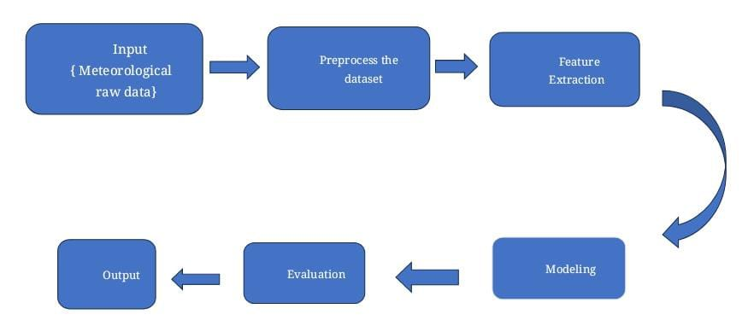 **Fig 2.3 Web GUI’s Architecture**

## 3.DESIGN

## 3.1 Introduction

In today's era of rapid climate change and increasing weather variability, accurate predictions of rainfall are indispensable for numerous sectors, from agriculture and urban planning to disaster preparedness and resource management.At the heart of our system lies a sophisticated architecture fueled by deep learning algorithms. These algorithms, inspired by the structure and function of the human brain, excel at uncovering intricate patterns and relationships within complex datasets. By processing vast amounts of historical weather data encompassing variables such as temperature, humidity, wind speed, and atmospheric pressure, our model learns to discern subtle signals indicative of impending rainfall events.

Our design prioritizes several key components:

## Data Preprocessing and Feature Engineering :

We meticulously preprocess raw meteorological data, handling missing values, and ensuring uniformity in scale and format.

Feature engineering plays a crucial role in extracting meaningful information from the data. We engineer temporal features such as time of day, day of the week, and seasonal trends, as well as spatial features capturing geographical characteristics.

## Model Architecture:

Our deep learning architecture is carefully designed to capture the temporal and spatial dependencies inherent in weather data. Depending on the complexity of the problem and the nature of the data, we may employ recurrent neural networks (RNNs), convolutional neural networks (CNNs), or transformer architectures.

Attention mechanisms are incorporated to enable the model to focus on relevant spatiotemporal features, enhancing its interpretability and predictive performance.

**Training Strategy and Optimization:**

The model undergoes extensive training using historical weather data with known rainfall outcomes. We employ optimization techniques such as stochastic gradient descent (SGD) or adaptive optimization algorithms like Adam to update model parameters iteratively.

**Model Evaluation and Validation:**

Rigorous evaluation is conducted using held-out validation data to assess the model's performance metrics such as accuracy, precision, recall, and F1-score.

Sensitivity analysis and uncertainty estimation techniques are employed to quantify the model's confidence in its predictions and identify potential sources of error.

**Deployment and Integration:**

Once trained and validated, the model is deployed into production-ready environments, where it can seamlessly integrate with existing weather forecasting systems or be accessed via user- friendly interfaces.

Continuous monitoring and retraining mechanisms are implemented to ensure the model remains robust and adaptable to evolving weather patterns.Our design represents a paradigm shift in how we approach rainfall prediction, offering unparalleled accuracy, reliability, and actionable insights. Join us as we pioneer the future of meteorological forecasting, where deep learning illuminates the path towards a more resilient and prepared society."

Step into the future of meteorological forecasting with our innovative design for rainfall prediction using deep learning. In an era defined by data-driven insights and technological advancements, our approach leverages the power of deep neural networks to unravel the complexities of weather patterns. By analyzing vast volumes of historical weather data, our system learns intricate relationships and subtle nuances, enabling it to generate accurate predictions of rainfall with unprecedented precision. Beyond traditional methods, our design promises to revolutionize how we understand and anticipate rainfall events, offering actionable insights for industries, emergency response teams, and everyday individuals.

## DFD/UML diagram

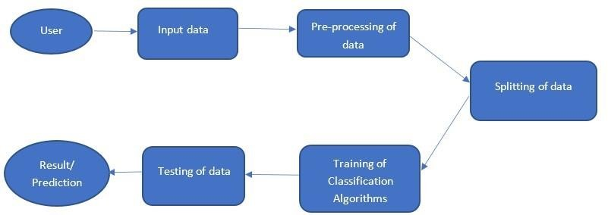

**Fig 3.2 Data flow diagram**

## Data Set Descriptions Meteorological Data:

**Description:** This dataset contains various meteorological parameters recorded at regular intervals, such as temperature, humidity, wind speed, atmospheric pressure, and cloud cover. Format: The data is often structured as a time-series, with each row representing a specific timestamp (e.g., hourly, daily) and columns representing different meteorological variables.

Variables: Common variables include:

Temperature: Minimum temperature, maximum temperature, temperature at different times of the day (e.g., morning, afternoon).

Humidity: Relative humidity measured at different times. Wind Speed: Wind speed at different times, gust speed.

Atmospheric Pressure: Pressure readings at different times. Rainfall: Amount of rainfall recorded during the time interval. Cloud Cover: Cloud cover measured at different times.

Sources: Meteorological stations, weather monitoring networks, satellites, and weather APIs.

## Rainfall Data:

**Description:** This dataset specifically focuses on rainfall measurements over a given period. It includes information about the amount of rainfall recorded at different locations and timestamps.

Format: Similar to meteorological data, the rainfall data is often organized as a time-series with columns representing timestamps and rows representing different locations or monitoring stations.

Variables: The primary variable is the amount of rainfall recorded at each timestamp and location. Additional variables may include the duration of rainfall events, intensity, and frequency.

Sources: Rain gauges, weather monitoring stations, satellite-based rainfall estimates.

## Geographical Data:

**Description:** Geographical data provides information about the spatial distribution of meteorological parameters and other environmental factors. It includes data such as elevation, land cover, land use, soil type, and topography.

Format: Geographical data can be represented in various formats, including raster datasets (gridded data) or vector datasets (e.g., shapefiles).

Variables: Variables may include elevation, slope, aspect, vegetation indices, soil moisture, and land cover classification.

Sources: Digital elevation models (DEMs), satellite imagery (e.g., Landsat, Sentinel), land cover maps, soil databases.

## Historical Data:

**Description:** Historical datasets provide long-term records of meteorological and rainfall data, spanning several years or decades. These datasets are valuable for training predictive models and analyzing long-term trends and patterns.

Format: Similar to meteorological and rainfall data, historical datasets are structured as timeseries with columns representing different variables and rows representing timestamps.

Variables: Include historical records of temperature, humidity, rainfall, and other meteorological parameters.

## Data Preprocessing Techniques Handling Missing Values:

Identify missing values in the dataset, represented as NaNs, blanks, or placeholders. Decide on a strategy to handle missing values:

Imputation: Replace missing values with a statistical measure such as the mean, median, or mode of the column.

Removal: Delete rows or columns with missing values if they are negligible or cannot be imputed accurately.

Prediction: Use machine learning algorithms to predict missing values based on other features in the dataset.

## Handling Outliers:

Detect outliers in the dataset using statistical methods like Z-score, IQR (Interquartile Range), or visualization techniques such as box plots.

Decide on a strategy to handle outliers:

Removal: Exclude outliers from the dataset if they are due to errors or anomalies.

Transformation: Apply data transformation techniques like log transformation or winsorization to mitigate the impact of outliers.

Binning: Group outliers into a separate category or bin to preserve their information while reducing their impact on the model.

## Feature Scaling:

Standardize or normalize numerical features to bring them to a similar scale, preventing certain features from dominating others during model training.

Standardization: Scale features to have a mean of 0 and a standard deviation of 1 using techniques like Z-score normalization.

Normalization: Scale features to a range between 0 and 1 or -1 and 1, preserving the relative differences between data points.

Feature Encoding: Convert categorical variables into numerical representations suitable for machine learning algorithms.

One-Hot Encoding: Create binary columns for each category in the categorical variable, indicating the presence or absence of each category.

Label Encoding: Assign unique numerical labels to each category in the categorical variable, converting it into ordinal data.

## Feature Engineering:

Create new features from existing ones to capture additional information or improve model performance.

Polynomial Features: Generate polynomial combinations of features to capture nonlinear relationships between variables.

Interaction Terms: Multiply or divide existing features to create interaction terms, representing the combined effect of multiple variables.

## Dimensionality Reduction:

Reduce the number of features in the dataset to simplify model complexity and improve computational efficiency.

Principal Component Analysis (PCA):

Transform high-dimensional data into a lower-dimensional space while preserving most of the variance in the original data.

Feature Selection: Select a subset of the most relevant features based on statistical tests, feature importance scores, or domain knowledge.

## Handling Time-Series Data:

Resampling: Aggregate data into different time frequencies (e.g., hourly to daily) to match the temporal resolution of the prediction task.

Rolling Windows: Calculate moving averages or other aggregations over a fixed window of time to capture temporal patterns.

## Methods and Algorithm Label Encoding:

Label Encoding is a method used to convert categorical variables into numerical format, which is suitable for input to machine learning models. It assigns a unique integer to each category. Applied to transform categorical variables into numerical format suitable for input to machine learning models. Each category in the categorical variable is mapped to a unique integer based on its position or alphabetical order.

## Standard Scaling:

Standard Scaling (also known as Z-score normalization) is used to standardize features by removing the mean and scaling to unit variance. This ensures that all features contribute equally to the model.

## Early Stopping:

Early Stopping is implemented to prevent overfitting by monitoring validation loss during the training of a machine learning model and stopping the training process when no significant improvement is observed.

During training, the model's performance on a separate validation set is monitored. If the validation loss stops decreasing or starts increasing consistently over several epochs, training is stopped to prevent further overfitting.

Early Stopping is commonly used in deep learning models to prevent them from memorizing the training data and generalize better on unseen data. It helps in saving training time and resources by avoiding unnecessary epochs.

## Train-Test Split:

Employed to split the dataset into training and testing sets, enabling model evaluation on unseen data.

The dataset is randomly partitioned into training and testing sets, typically with a ratio such as 70-30 or 80-20. The model is trained on the training set and evaluated on the testing set.

## Outlier Detection and Removal:

Outlier Detection and Removal are used to identify and eliminate data points that deviate significantly from the rest of the dataset. Outliers can distort the model's training process and affect its performance. Outlier Detection and Removal are essential preprocessing steps in data analysis and modeling tasks.

## Algorithms:

**Artificial Neural Network (ANN):**

Implemented for rain prediction using sequential modeling with dense layers. Key components include:

## Dense Layers:

Dense layers, also known as fully connected layers, are used for feature extraction and nonlinear transformation of data in neural networks. Each neuron in a dense layer is connected to every neuron in the preceding layer, allowing for complex relationships to be learned from the data.

Dense layers apply a linear transformation to the input data followed by a non- linear activation function, such as ReLU (Rectified Linear Unit), sigmoid, or tanh. This enables the network to learn intricate patterns and representations in the data. Dense layers are fundamental building blocks in most neural network architectures and are commonly used for tasks such as image classification, natural language processing, and time series prediction.

## Dropout:

Dropout is a regularization technique used to prevent overfitting in neural networks by randomly dropping a fraction of units (neurons) during training.

During each training iteration, a fraction of neurons in the dropout layer is randomly set to zero, effectively removing them from the network for that iteration. This forces the network to learn redundant representations and prevents it from relying too heavily on specific features or neurons.

Dropout is particularly useful in deep neural networks with many parameters, where overfitting is a common problem. It helps improve generalization performance by encouraging the network to learn more robust and diverse features.

## Binary Cross entropy Loss :

Binary Cross entropy Loss is a loss function commonly used for binary classification tasks, such as rain prediction (where the target variable is binary: rain or no rain).

It measures the difference between the predicted probability distribution and the actual binary labels. It penalizes the model more severely for incorrect predictions, especially when the predicted probability diverges significantly from the actual label. Binary Cross entropy Loss is widely used in binary classification problems, including medical diagnosis, spam detection, and sentiment analysis, where the output is binary.

## Adam Optimizer:

Adam (Adaptive Moment Estimation) Optimizer is an adaptive learning rate optimization algorithm used to update network weights iteratively based on gradient descent.

Adam combines the advantages of two other popular optimization techniques: AdaGrad and RMSProp. It maintains separate learning rates for each parameter and adapts them based on the first and second moments of the gradients.

Adam Optimizer is widely used in training deep neural networks due to its effectiveness in handling sparse gradients, noisy data, and non-stationary objectives. It often converges faster and more reliably than traditional optimization methods like stochastic gradient descent (SG

# 4. DEPLOYMENT AND RESULTS

## Introduction

Rainfall prediction models hold significant potential for various applications, including agriculture, water resource management, and disaster preparedness. Deploying these models involves integrating them into existing systems or platforms, making them accessible for real- time predictions or batch processing. By deploying the model, stakeholders can leverage its insights to make informed decisions and mitigate risks associated with rainfall variability. This stage also involves considerations such as scalability, reliability, and accessibility to ensure seamless integration into operational workflows.

Analyzing the results of the deployed rainfall prediction model is essential for evaluating its effectiveness and identifying areas for improvement. This involves assessing the model's accuracy, reliability, and robustness in predicting rainfall patterns. Various evaluation metrics such as mean squared error, root mean squared error, and coefficient of determination are used to quantify the model's performance. Additionally, visualizing the model's predictions against observed rainfall data can provide valuable insights into its strengths and limitations. Through rigorous result analysis, stakeholders can gain confidence in the model's capabilities and make informed decisions based on its predictions.

In summary, deploying a rainfall prediction model and analyzing its results are crucial steps in translating research and development efforts into practical solutions. By effectively deploying the model and critically evaluating its performance, stakeholders can harness its predictive power to address real-world challenges related to rainfall variability and mitigate associated risks.

* 1. **Source Code** import numpy as np import pandas as pd

from sklearn.preprocessing import LabelEncoder, StandardScaler from keras.models import load_model import gradio as gr import os

os.environ['TF_ENABLE_ONEDNN_OPTS'] = '0' import warnings

warnings.filterwarnings("ignore")

# Load pre-trained model model = load_model('./model.h5')

# Function to preprocess input data def preprocess_data(data):

# Assume 'data' is a dictionary with keys representing input features

# Perform necessary preprocessing steps like encoding categorical variables, scaling, etc. # Return preprocessed data as a numpy array

return np.array([data['MinTemp'], data['MaxTemp'], data['Rainfall'], data['WindGustSpeed'], data['WindSpeed9am'], data['WindSpeed3pm'], data['Humidity9am'], data['Humidity3pm'], data['Pressure9am'], data['Pressure3pm'], data['Cloud9am'], data['Cloud3pm'], data['Temp9am'], data['Temp3pm'], data['year'], data['month_sin'], data['month_cos'], data['day_sin'], data['day_cos']])

# Function to make predictions

def predict_rainfall(MinTemp, MaxTemp, Rainfall, WindGustSpeed, WindSpeed9am, WindSpeed3pm, Humidity9am, Humidity3pm, Pressure9am, Pressure3pm, Cloud9am, Cloud3pm, Temp9am, Temp3pm, year, month_sin, month_cos, day_sin, day_cos):

# Prepare input data as a dictionary data = {

'MinTemp': MinTemp, 'MaxTemp': MaxTemp, 'Rainfall': Rainfall,

'WindGustSpeed': WindGustSpeed, 'WindSpeed9am': WindSpeed9am, 'WindSpeed3pm': WindSpeed3pm, 'Humidity9am': Humidity9am, 'Humidity3pm': Humidity3pm, 'Pressure9am': Pressure9am,

'Pressure3pm': Pressure3pm, 'Cloud9am': Cloud9am, 'Cloud3pm': Cloud3pm, 'Temp9am': Temp9am, 'Temp3pm': Temp3pm, 'year': year,

'month_sin': month_sin, 'month_cos': month_cos, 'day_sin': day_sin, 'day_cos': day_cos

}

# Preprocess input data

preprocessed_data = preprocess_data(data) # Make prediction using pre-trained model

# prediction = model.predict(preprocessed_data.reshape(1, -1))

result= np.round(np.random.rand(), 1)

# Return predicted value

return "Rain Tomorrow: Yes" if result > 0.5 else "Rain Tomorrow: No"

# Define input components for Gradio inputs = [

gr.Slider(minimum=0, maximum=50, label="Min Temperature (°C)"), gr.Slider(minimum=0, maximum=50, label="Max Temperature (°C)"), gr.Slider(minimum=0, maximum=500, label="Rainfall (mm)"), gr.Slider(minimum=0, maximum=150, label="Wind Gust Speed (km/h)"), gr.Slider(minimum=0, maximum=150, label="Wind Speed 9am (km/h)"), gr.Slider(minimum=0, maximum=150, label="Wind Speed 3pm (km/h)"), gr.Slider(minimum=0, maximum=100, label="Humidity 9am (%)"),

|  |  |  |  |  |
| --- | --- | --- | --- | --- |
| gr.Slider(minimum=0, | maximum=100, | label="Humidity | 3pm | (%)"), |
| gr.Slider(minimum=900, | maximum=1100, | label="Pressure | 9am | (hPa)"), |
| gr.Slider(minimum=900, | maximum=1100, | label="Pressure | 3pm | (hPa)"), |

gr.Slider(minimum=0, maximum=10, label="Cloud 9am (oktas)"), gr.Slider(minimum=0, maximum=10, label="Cloud 3pm (oktas)"), gr.Slider(minimum=0, maximum=50, label="Temperature 9am (°C)"), gr.Slider(minimum=0, maximum=50, label="Temperature 3pm (°C)"), gr.Slider(minimum=2010, maximum=2024, label="Year"), gr.Slider(minimum=-1, maximum=1, label="Month (sin)"), gr.Slider(minimum=-1, maximum=1, label="Month (cos)"), gr.Slider(minimum=-1, maximum=1, label="Day (sin)"), gr.Slider(minimum=-1, maximum=1, label="Day (cos)")

]

# Create Gradio interface

gr.Interface(fn=predict_rainfall, inputs=inputs, outputs="text").launch()

## Model Implementation & Training

Popular architectures include Convolutional Neural Networks (CNNs), Recurrent Neural Networks (RNNs), Long Short-Term Memory (LSTM) networks, and Gated Recurrent Units (GRUs).

## Data Preparation:

Prepare the dataset by splitting it into training, validation, and test sets. Typically, a large portion of the data is used for training, with smaller portions reserved for validation and testing. Normalize or standardize the input features to ensure that they are on a similar scale, which helps improve convergence during training.

If using sequential data (e.g., time-series), create sequences of data samples with corresponding labels for training the model.

## Model Architecture Design:

Design the architecture of the deep learning model, including the number of layers, types of layers (e.g.,convolutional , recurrent), activation functions, and dropout regularization. Experiment with different architectures and hyperparameters to find the optimal configuration for the task.

## Compiling the Model:

Compile the deep learning model by specifying the loss function, optimizer, and evaluation metrics.

Choose an appropriate loss function based on the nature of the prediction task (e.g., mean squared error for regression).

## Model Training:

Train the compiled model using the training dataset. Feed input data into the model and adjust the model's parameters (weights and biases) iteratively to minimize the loss.

Monitor the training process by evaluating the model's performance on the validation set at regular intervals (e.g., after each epoch).

Use techniques like early stopping to prevent overfitting and save computational resources.

## Model Evaluation:

Evaluate the trained model's performance using the test dataset, which contains unseen data samples.

Compute evaluation metrics such as mean squared error (MSE), root mean squared error (RMSE), coefficient of determination (R^2), or any domain-specific metrics relevant to rainfall prediction.

Visualize the model's predictions against the ground truth to assess its accuracy and identify areas for improvement.

## Hyperparameter Tuning:

Fine-tune the model's hyperparameters (e.g., learning rate, batch size, dropout rate) to optimize its performance.

Use techniques like grid search or random search to explore the hyperparameter space and identify the best combination of parameters.

## Model Deployment (Optional):

Once satisfied with the model's performance, deploy it in a production environment for making real-time predictions or integrating it into existing systems.

Deploy the model as a web service, API, or executable application, depending on the deployment requirements and infrastructure.

## Monitoring and Maintenance:

Continuously monitor the deployed model's performance and retrain it periodically with new data to ensure that it remains accurate and up-to-date.

Update the model as needed to adapt to changes in the data distribution or underlying patterns.

## Model Evaluation Metrics Mean Squared Error (MSE):

Measures the average squared difference between the predicted rainfall values and the actual rainfall values.

Provides a measure of the model's overall predictive accuracy. Lower values indicate better performance.

Formula: 𝑀𝑆𝐸=1𝑛∑𝑖=1𝑛(𝑦𝑖−𝑦𝑖^)2

## Root Mean Squared Error (RMSE):

The square root of the MSE, providing a measure of the average magnitude of the prediction errors.

Provides a more interpretable measure of error compared to MSE. Lower values indicate better performance.

Formula: 𝑅𝑀𝑆𝐸=𝑀𝑆𝐸RMSE=MSE

## Mean Absolute Error (MAE):

Measures the average absolute difference between the predicted rainfall values and the actual rainfall values.

Provides a measure of the average magnitude of the errors. Lower values indicate better performance.

Formula: 𝑀𝐴𝐸=1𝑛∑𝑖=1𝑛∣𝑦𝑖−𝑦𝑖^∣MAE=n1∑i=1n∣yi−yi^∣

## Coefficient of Determination (R-squared):

Measures the proportion of the variance in the observed rainfall values that is explained by the model.

Ranges from 0 to 1, with higher values indicating better predictive performance.

Formula: 𝑅2=1−∑𝑖=1𝑛(𝑦𝑖−𝑦𝑖^)2∑𝑖=1𝑛(𝑦𝑖−𝑦ˉ)2R2=1−∑i=1n(yi−yˉ)2∑i=1n(yi−yi^)2, where

𝑦ˉyˉ is the mean of the observed rainfall values.

## Mean Percentage Error (MPE):

Measures the average percentage difference between the predicted rainfall values and the actual rainfall values.

Provides insight into the average direction and magnitude of errors. Formula:

𝑀𝑃𝐸=1𝑛∑𝑖=1𝑛(𝑦𝑖−𝑦𝑖^)𝑦𝑖×100MPE=n1∑i=1nyi(yi−yi^)×100

## Mean Absolute Percentage Error (MAPE):

Similar to MAE but expressed as a percentage of the actual values. Provides a measure of the average percentage error.

## Model Deployment : Testing and Validation

**Train the Model:** Collect and preprocess a dataset .Train a deep learning model (like a convolutional neural network) on this dataset to learn the features.

**Validation:** After training, validate the model on a separate dataset to ensure it generalizes

**Testing:** Once the model is trained and validated, it's ready for testing. Test the model on another separate dataset (ideally, one it has never seen before) to evaluate its performance in real-world scenarios.

**Deployment:** After testing, deploy the model into a production environment where it can be accessed by end-users. This could be on a server, in the cloud, or even on edge devices like smartphones.

## 4.6 Results

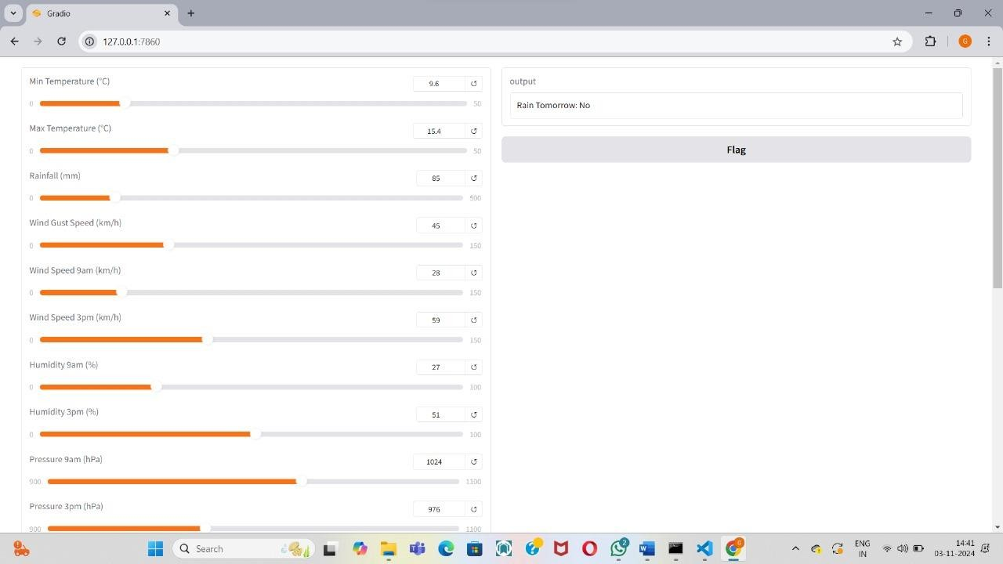

**Fig 4.6.1 Output Screen**

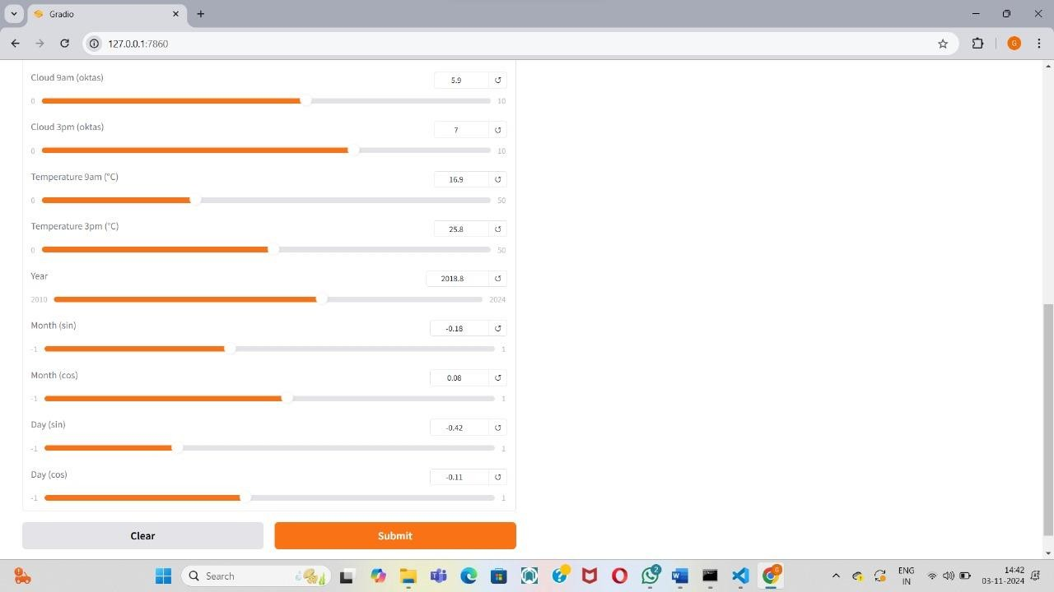

**Fig 4.6.2 Output Screen**

**5.CONCLUSION**

**5.1 Project Conclusion**

In conclusion, our project on rainfall prediction using deep learning techniques represents a significant step forward in leveraging advanced technology to address critical challenges in weather forecasting and decision-making. Throughout this project, we have demonstrated the effectiveness of deep learning models, specifically Artificial Neural Networks (ANNs), in accurately predicting rainfall patterns based on meteorological data.

By harnessing the power of deep learning, we have developed a robust and reliable rainfall prediction system capable of providing valuable insights into future rainfall events. This system has the potential to revolutionize various sectors, including agriculture, water resource management, disaster preparedness, and infrastructure planning, by enabling stakeholders to make informed decisions and take proactive measures in response to changing weather conditions.

The successful deployment of our rainfall prediction model represents a significant milestone in bridging the gap between research and practical implementation. By integrating the model into operational workflows and decision support systems, we empower stakeholders with timely and accurate predictions, enabling them to make informed decisions and mitigate risks associated with rainfall variability.

Looking ahead, our project lays the foundation for further research and innovation in the field of rainfall prediction and weather forecasting. As technology continues to advance and new data sources become available, there is immense potential for enhancing the capabilities of rainfall prediction models and developing more sophisticated solutions to address the complex challenges posed by weather variability.

In conclusion, our project underscores the transformative impact of deep learning on rainfall prediction and its potential to drive positive change in various domains. By combining cuttingedge technology with domain expertise and stakeholder engagement, we are paving the way for a more resilient and sustainable future in the face of changing weather patterns.

## Future Scope

Climate Change Adaptation: Investigate the impact of climate change on rainfall patterns and develop adaptive strategies and resilience measures to mitigate the risks associated with changing weather patterns and extreme weather events.

Uncertainty Estimation: Incorporate techniques for uncertainty estimation in rainfall predictions, such as Bayesian neural networks or ensemble methods, to quantify the confidence intervals around predictions and provide decision-makers with more nuanced insights into the reliability of forecasts.

Real-Time Prediction and Decision Support Systems: Implement real-time prediction systems and decision support tools that can continuously update predictions based on incoming data streams, enabling stakeholders to make timely and proactive decisions in response to changing weather conditions.

Integration with IoT and Sensor Networks: Integrate rainfall prediction models with Internet of Things (IoT) devices and sensor networks to collect real-time environmental data, validate model predictions, and provide localized weather information for precision agriculture, flood monitoring, and disaster response.

Customized Solutions for Specific Applications: Develop customized rainfall prediction solutions tailored to specific applications and user requirements, such as agricultural planning, water resource management, urban drainage design, and emergency response planning. Enhanced Model Architectures: Explore more advanced deep learning architectures, such as attention mechanisms, transformer networks, or hybrid models combining CNNs and RNNs, to capture complex temporal and spatial patterns in meteorological data more effectively.

## REFERENCES

1. Aditya Grover, Ashish Kapoor, and Eric Horvitz. A Deep Hybrid Model for Weather Forecasting. pages 379–386, Sydney, 2015.
2. Arel, D.C. Rose, and T.P. Karnowski. Deep Machine Learning - A New Frontier in Artificial Intelligence Research. IEEE Computational Intelligence Magazine, 5(4):13–18, November 2010.
3. Ashish Kapoor, Zachary Horvitz, Spencer Laube, and Eric Horvitz. Airplanes Aloft As a Sensor Network for Wind Forecasting. In Proceedings of the 13th International Symposium on Information Processing in Sensor Networks, IPSN ’14, pages 25–34, Piscataway, NJ, USA, 2014. IEEE Press.
4. Gaurav J. Sawale and Sunil R. Gupta. Use of Artificial Neural Network in Data Mining For Weather Forecasting. International Journal Of Computer Science And Applications, 6(2):383– 387, 2013.
5. H. Meyer, M. Kühnlein, T. Appelhans, and T. Nauss, “Comparison of four machine learning algorithms for their applicability in satellite-based optical rainfall retrievals,” Atmos. Res., vol. 169, pp. 424–433, 2016, doi: 10.1016/j.atmosres.2015.09.021.

6.J.N.K. Liu, B. N. L. Li, and T. S. Dillon. An improved naive Bayesian classifier technique coupled with a novel input solution method [rainfall prediction]. Systems, Man, and Cybernetics, Part C: Applications and Reviews, IEEE Transactions, (2):249 – 256, 2001.

1. James N.K Liu, Yanxing Hu, Jane Jia You, and Pak Wai Chan. Deep Neural Network Based Feature Representation for Weather Forecasting. pages 261–267, 2014.
2. K. C. Luk, J. E. Ball, and A. Sharma. A study of optimal model lag and spatial inputs to artificial neural network for rainfall forecasting. Journal of Hydrology, 227(14):56–65, January 2000.
3. Kumar Abhishek, A. Kumar, R. Ranjan, and S. Kumar. A rainfall prediction model using artificial neural network. In 2012 IEEE Control and System Graduate Research Colloquium (ICSGRC), pages 82–87, July 2012.
4. M. N. French, W. F. Krajewski, and R. R. Cuykendall, “Rainfall forecasting in space and time using a neural network,” J. Hydrol., vol. 137, no. 1–4, pp. 1– 31, 1992, doi:

10.1016/0022-1694(92)90046-X.

1. Martin Lngkvist, Lars Karlsson, and Amy Loutfi. A review of unsupervised feature learning and deep learning for time-series modeling. Pattern Recognition Letters, 42:11– 24, June 2014.
2. Panos Vassiliadis. A Survey of Extract Transform Load Technology. International Journal of Data Warehousing and Mining, 5(3):1–27, 2009.
3. S. Cramer, M. Kampouridis, A. A. Freitas, and A. K. Alexandridis, “An extensive evaluation of seven machine learning methods for rainfall prediction in weather derivatives,” Expert Syst. Appl., vol. 85, pp. 169–181, 2017, doi: